Login
- Student tries logging in with the wrong username or password -> error message saying incorrect user name or password / create new account
- Student tries logging in with the right username and password -> proceed to user dashboard (send passcode for challenge)
- Student creates new account with existing email -> error message saying already existing account
- Student creates new account with new email -> profile creation page (send passcode for challenge)
- Teacher tries logging in with the wrong username or password -> error message saying incorrect user name or password / create new account
- Teacher tries logging in with the right username and password -> proceed to user dashboard (send passcode for challenge)
- Teacher creates new account with existing email -> error message saying already existing account
- Teacher creates new account with new email -> profile creation page (send passcode for challenge)
Student – Teacher Interaction
- Student submits request to look for teachers -> list of three teachers matching the desired subjects show up in the ‘Find Teachers’ area (Ordered by familiarity: already established as tutor, gave feedback, same time zone)
- Student selects teacher from ‘Find Teachers’ area and sends request to the teacher and waits. Request is in a ‘waiting state’ until response from the teacher and the student can only delete the request now.
  - If student chooses to delete the request, the teacher will get a notification saying that the request was cancelled and they can no longer see it in their notification center
  - If not the request goes to the teachers notification center and stays there awaiting for approval or rejection. (If ‘immediate’ - give a specific time, if later ‘say when will match happen’)
  - If approved, the meeting is set up and the request gets completed with the teacher and student getting connected and being able to discuss their plans
  - If rejected, the request goes back to the ‘Find teachers’ section where the student can send the same request to a different teacher or the same teacher with a different time.
- The teachers will be able to view the students profile in the request and see a short explanation of what the student would like to achieve. Using the public profile they would decide whether to accept or decline the request and state a reason why. (Request should have notes on what students want to learn that session)
- The student can send in a request which is either an immediate tutor session or a scheduled one
  - The immediate scheduled can only be accepted or declined by the teacher
  - Later scheduled, can be accepted, declined or rescheduled
- The stages of a request will be: draft, sent and waiting for approval, declined, accepted, rescheduled, or cancelled
Student Dashboard
- The student can view their schedule when they want to in a calendar format and cancel any scheduled meetings which will delete the request and notify the teacher
- The student can view their past meetings in the same calendar section and see the small recap of their meeting with the teacher
- The student can edit their public profile which will be shown when people click their profile
- The student can change their settings and payment which will be private and only for them to use
- The student can view all important information on their dashboard which includes the subjects, teachers, and other immediate statistics they would like to see
Teacher Dashboard
- The teacher can view the requests sent to them on the requests page and they receive a notification when they do
- The teacher can also view their own schedule and modify the schedule by canceling a class which will send a notification for the student and will allow the student to find a new teacher for the same request
- The teacher can also view their past meetings and their past students and clicking on it will show them a small recap of what was taught which is written by the teacher and can be seen by both the student and the teacher
- The teacher can also change their settings and view their income by seeing how many hours they’ve worked and the time till their next invoice on their payment section
- The teacher can also see their own dashboard with all of the information immediately prevalent to them and the highlights of each of the previous sections

<add section with use cases regarding ongoing class>
First Time Login Student:
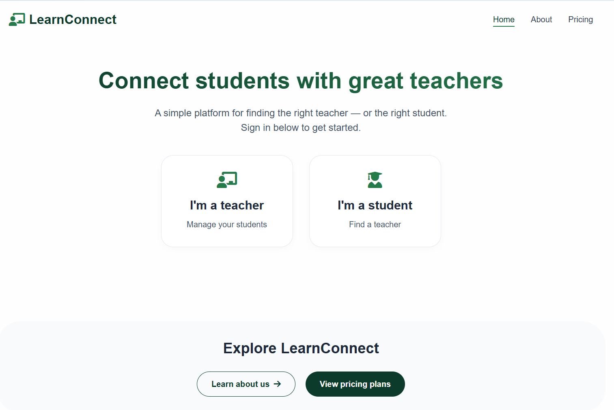
Start at homepage and click “I’m a student”
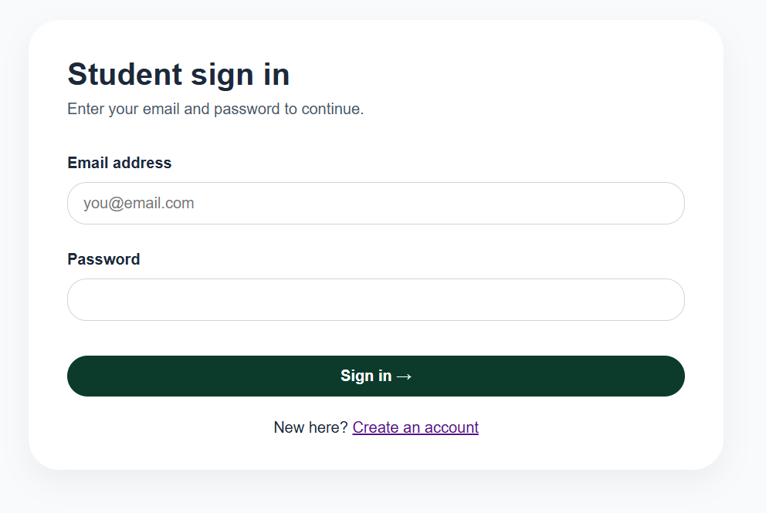
Prompted with the sign in page, if you submit email and password it will say incorrect username or password. You will have to click create an account to login if you do not have an account
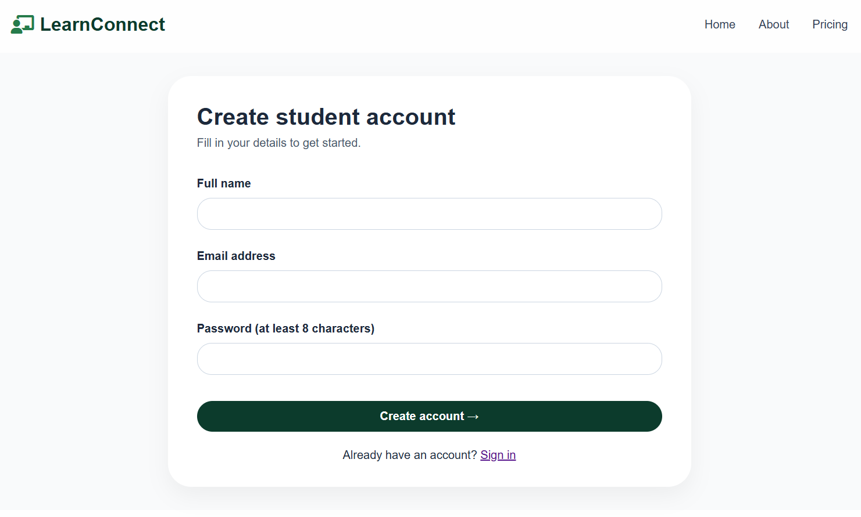
The first page to create the student account will ask for your name, email address and password to initially create your account. After filling that in with accepted values you will receive a confirmation email which will take you to the profile creation.
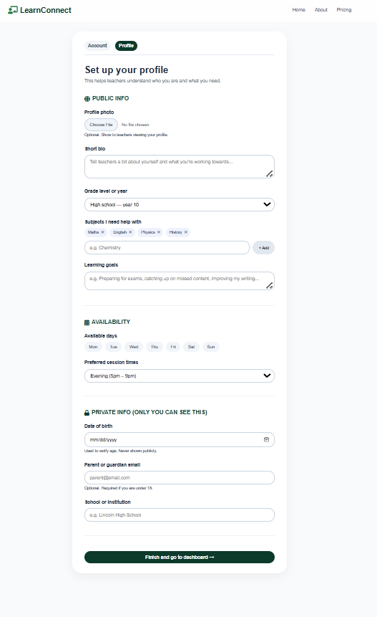
You will be prompted several questions here to fill out for your profile, some of which will be private and some of which would be public on your public profile for tutors to see.
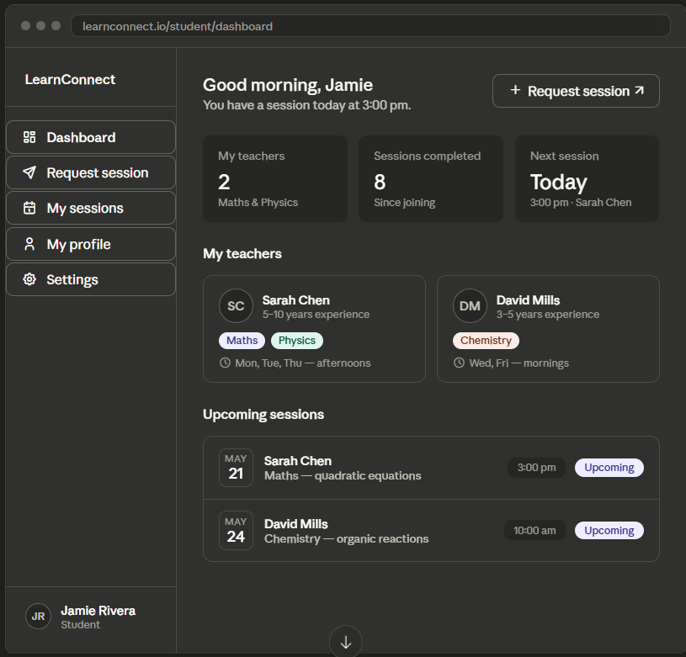
After that you will be taken to your dashboard which would be empty. You will be able to see your teachers, sessions, and your next sessions here when you eventually get more meetings.
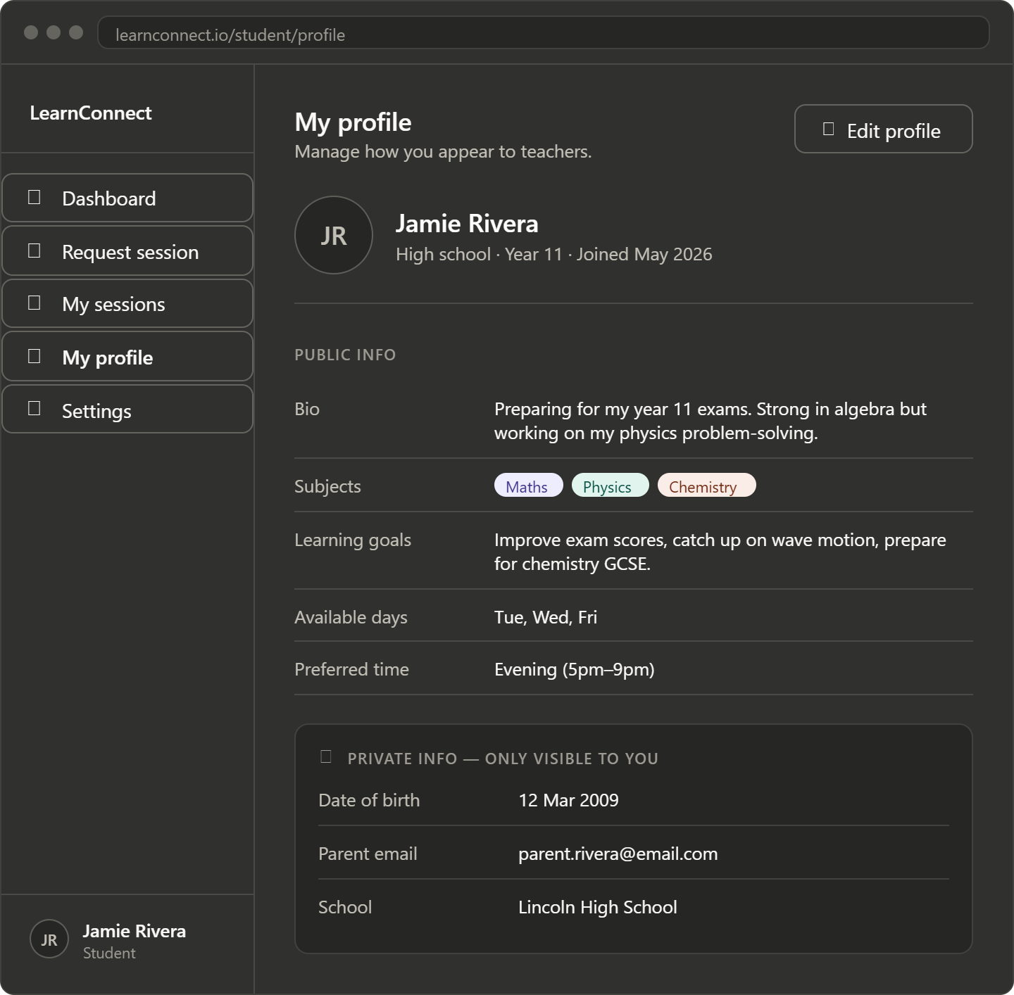
You can also see your profile and edit it to see what people viewing your profile will see
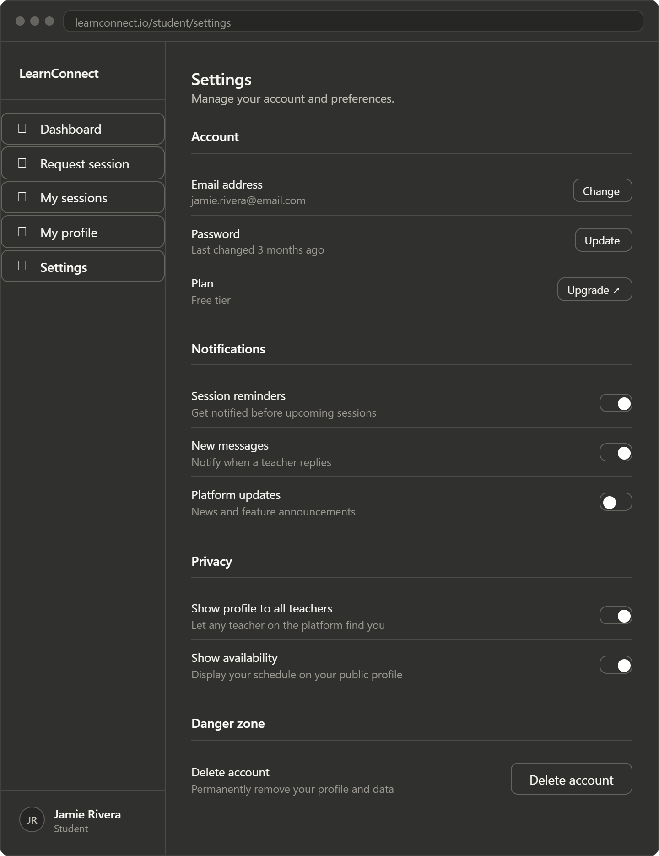You can also see your settings and payment information here and change anything you would like for better user experience
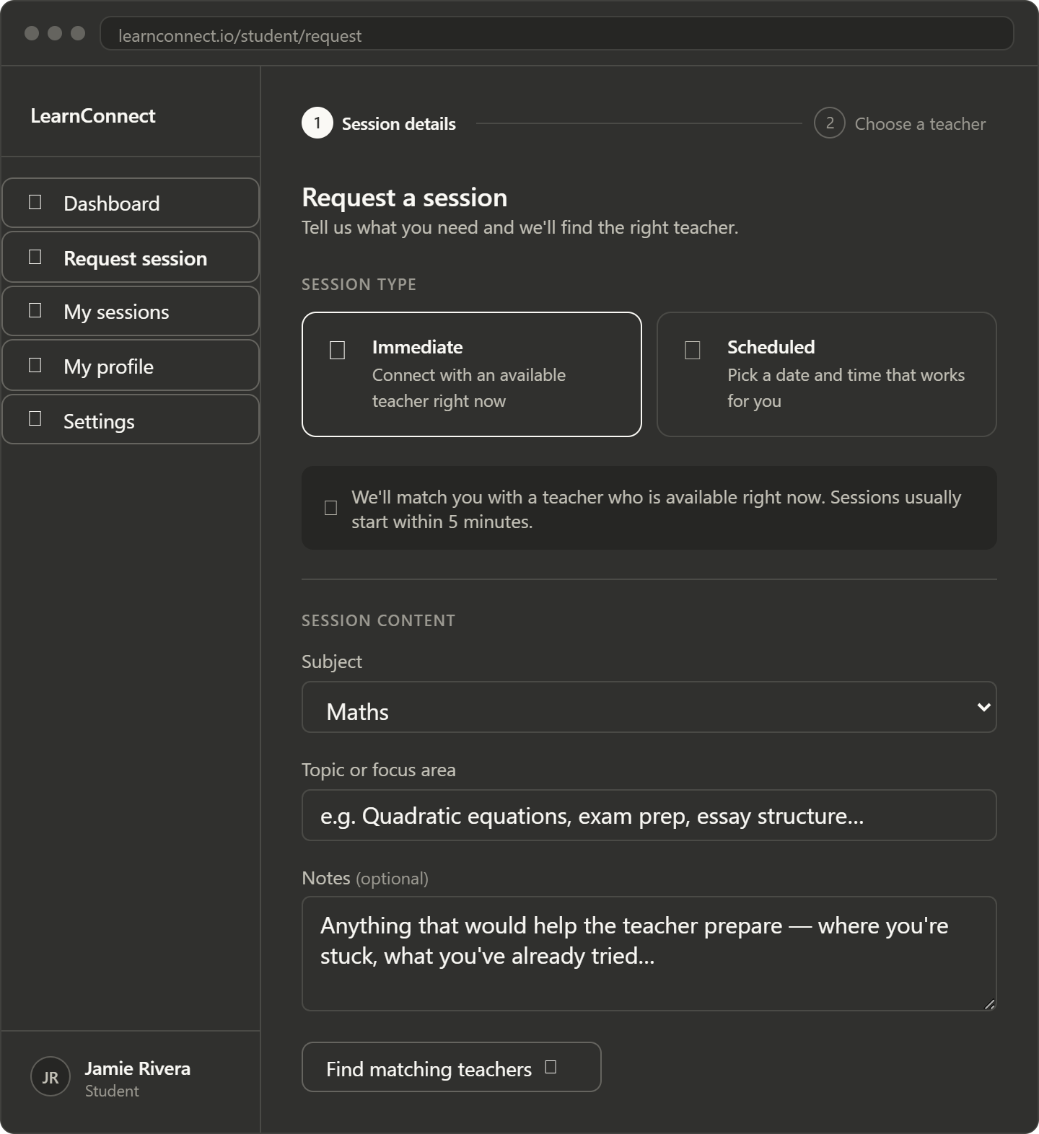\ 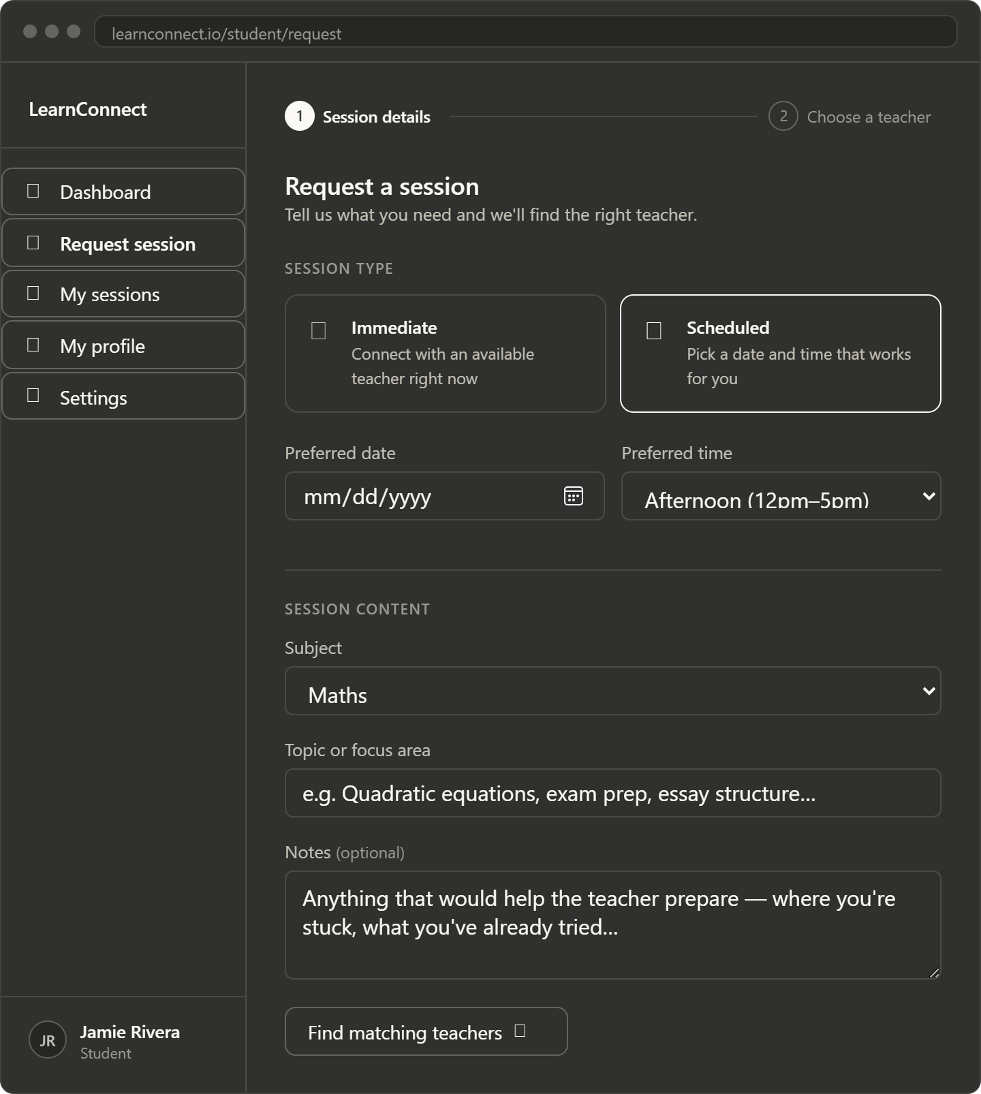
When you would like to set up a session you can go to the request session either immediately or for a scheduled time in the future. Once you finish the request you will be prompted to select a teacher
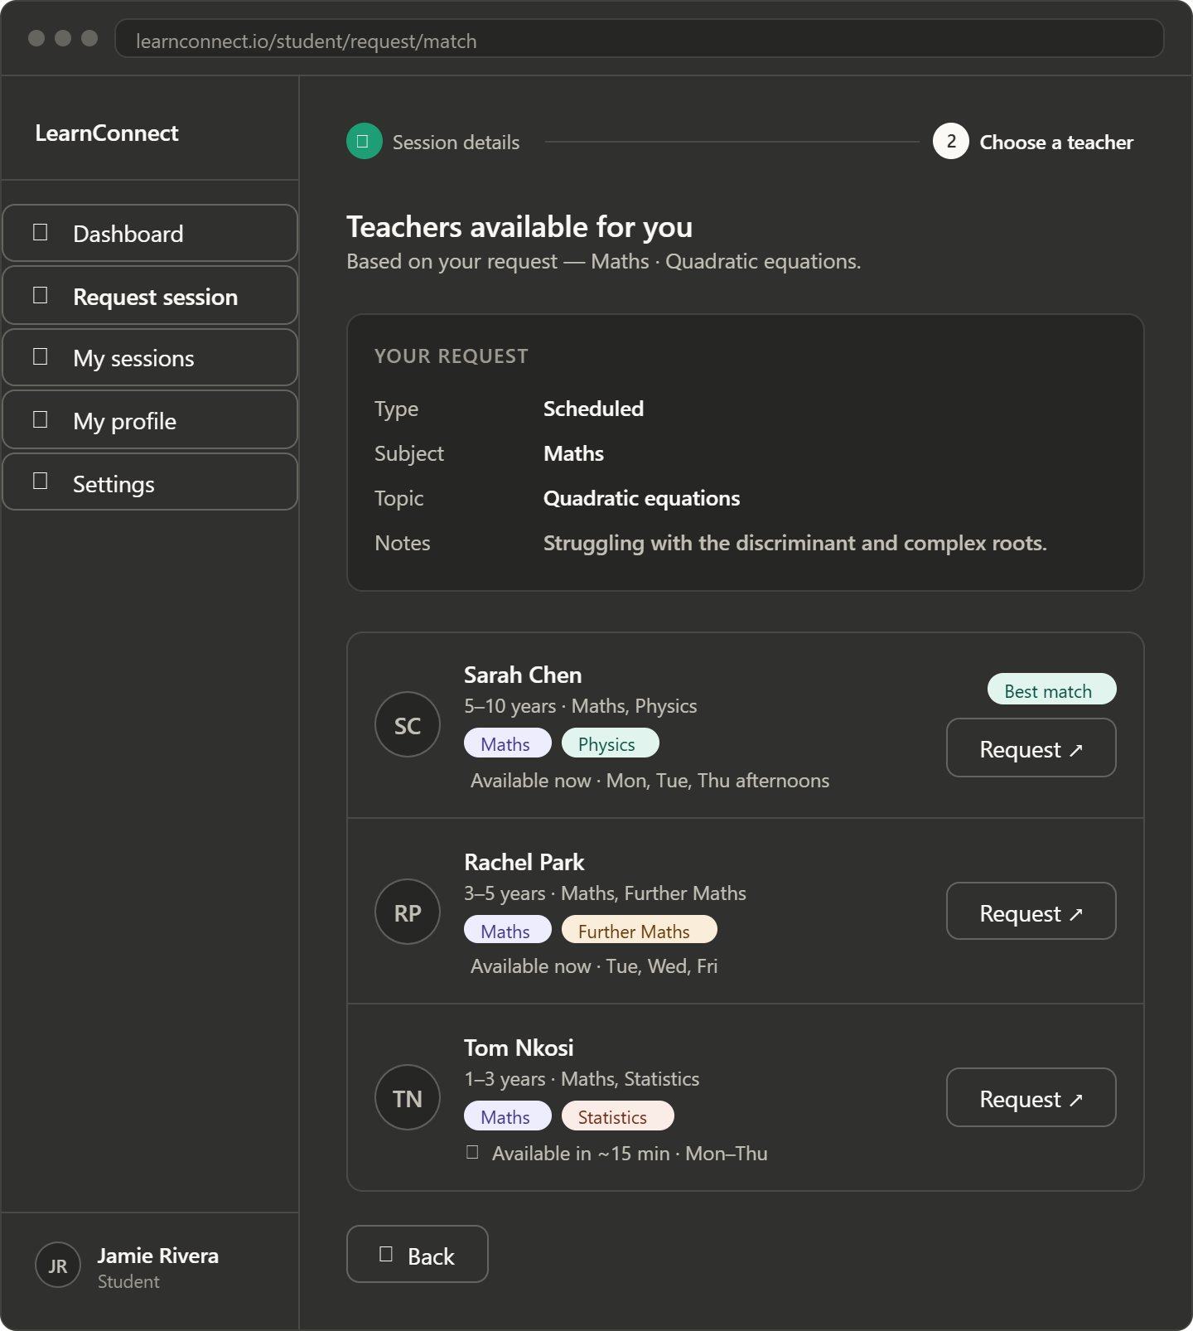
You will get a list of 3 specially chosen tutors for your needs which you can click on to view their profile and learn about them and see their experiences and their profile. You can select them to look into their profile as well. Once you click on the request you will wait for a response and will see the request in the ‘my sessions’ section

First Time Teacher

Start at homepage and click “I’m a teacher”

Prompted with the sign in page, if you submit email and password it will say incorrect username or password. You will have to click create an account to login if you do not have an account

The first page to create the student account will ask for your name, email address and password to initially create your account. After filling that in with accepted values you will receive a confirmation email which will take you to the profile creation.
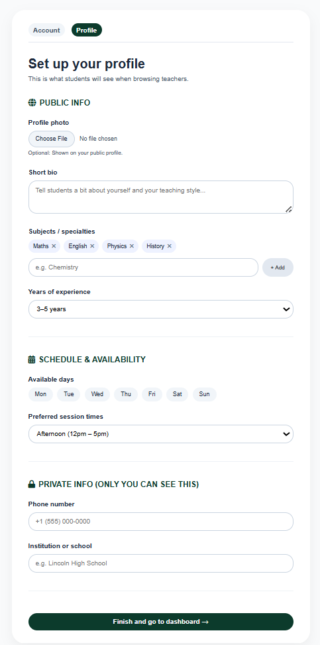
You will be prompted several questions here to fill out for your profile, some of which will be private and some of which would be public on your public profile for tutors to see.
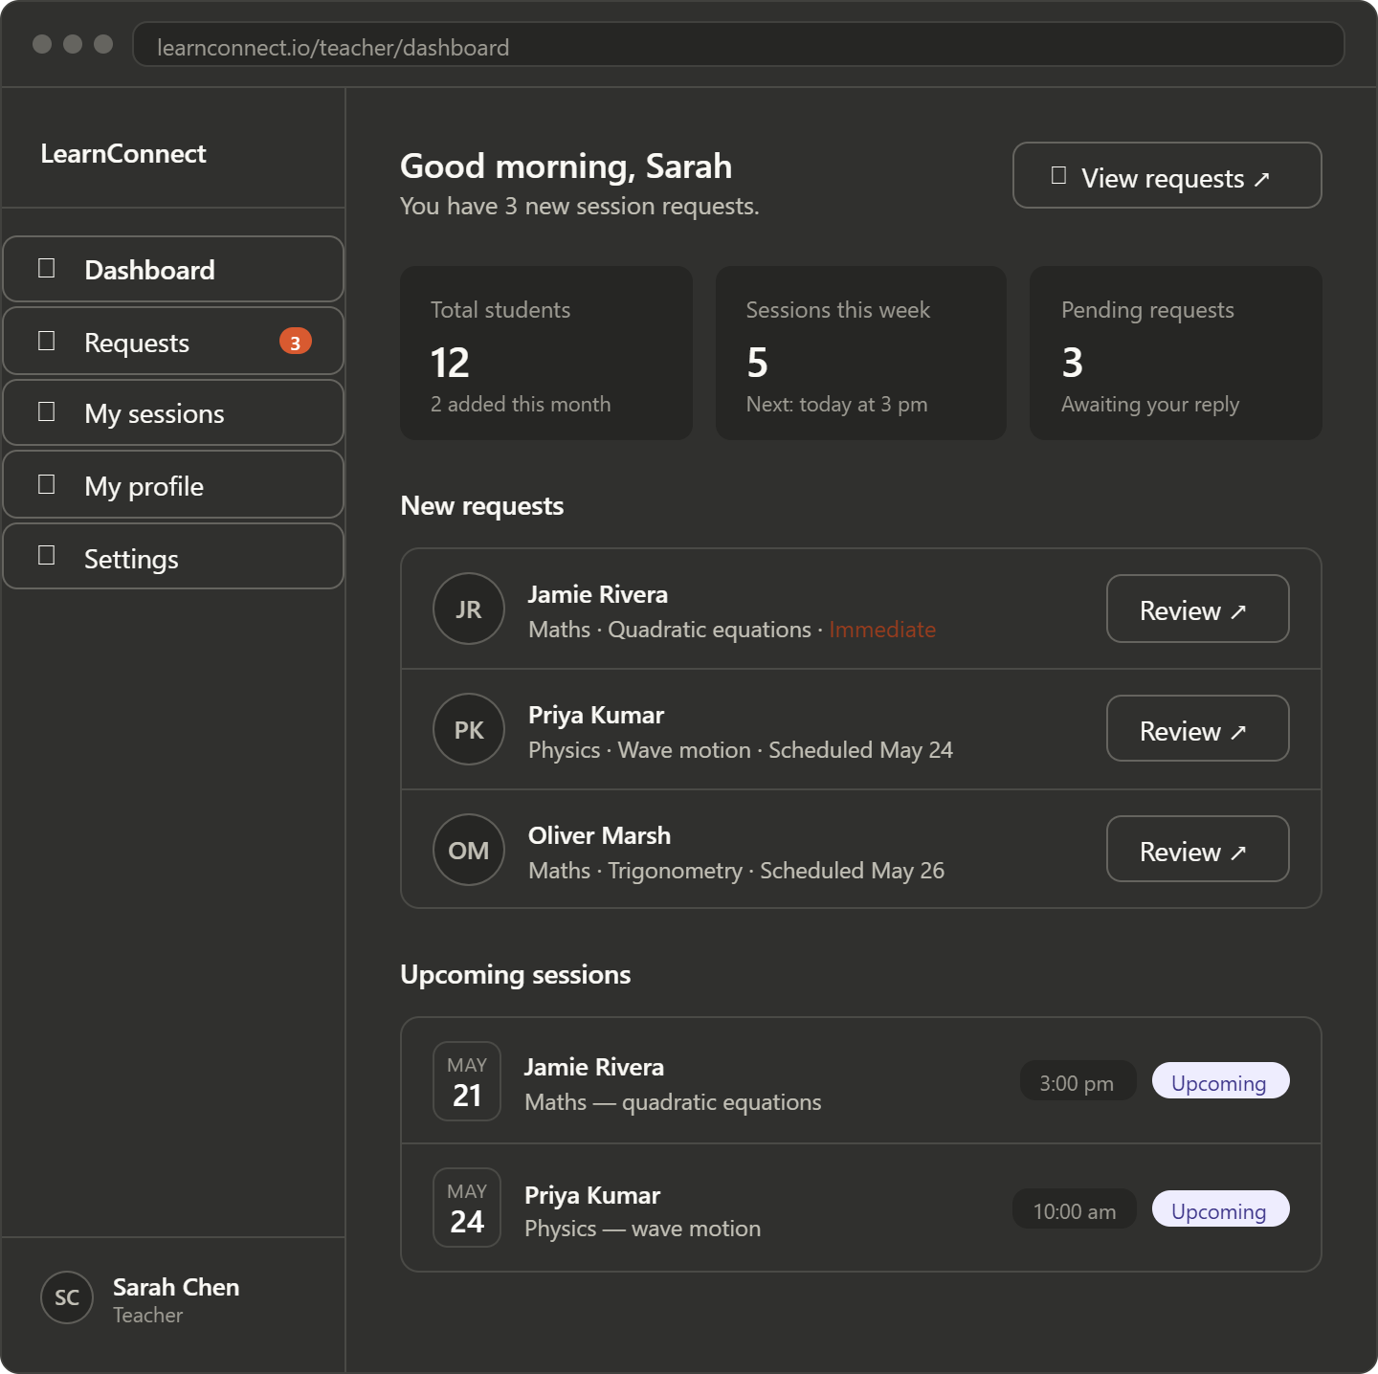
In the dashboard you will be able to see your students, sessions and the requests you have but this would be empty for the first time you log in.
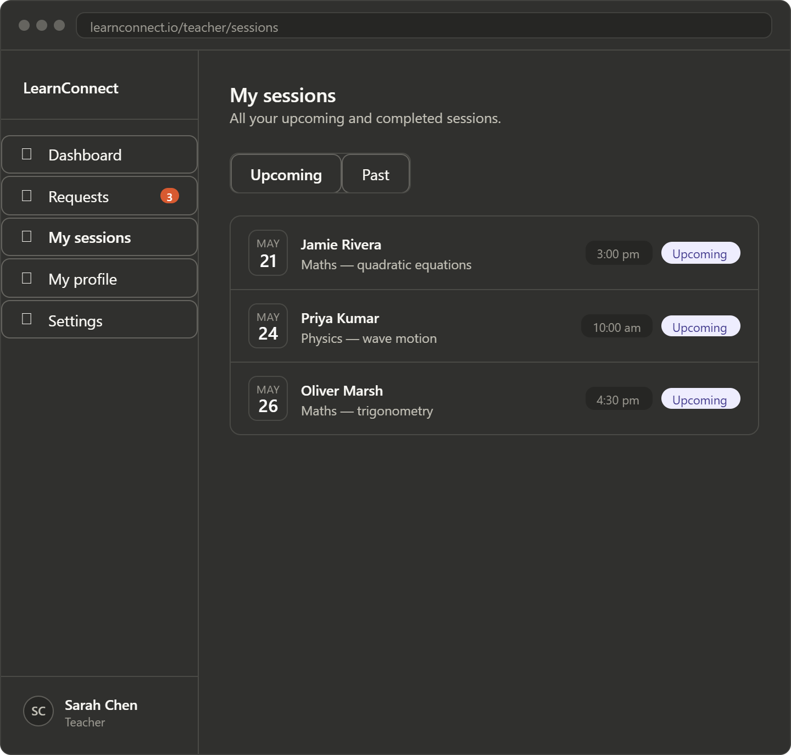
You will also be able to see your sessions as well as the students in your my sessions section where you can click on the student to view the profile or click on the box to view the request and the meeting link.
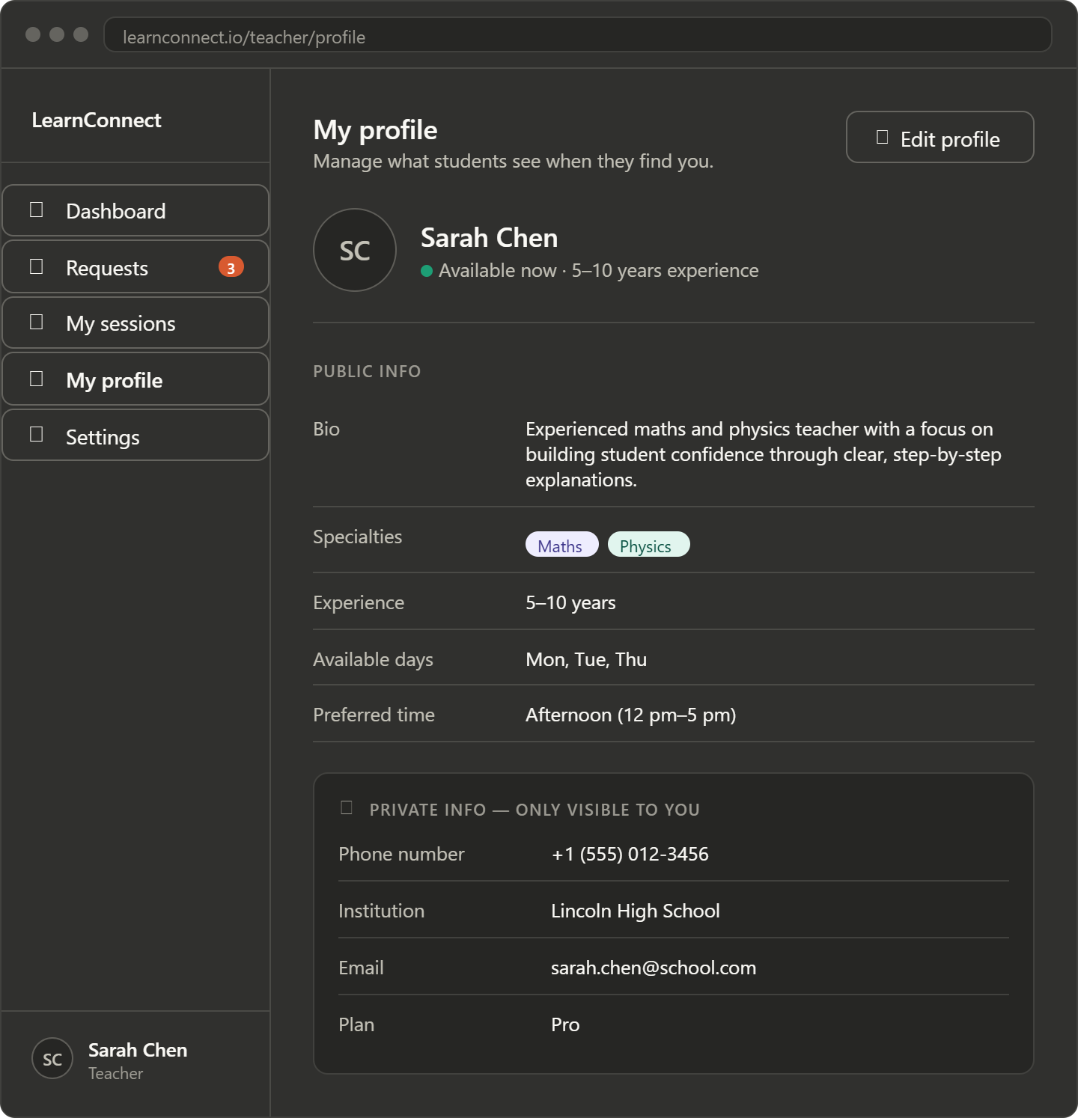You can also view and edit your profile which includes things like your bio and other parts of your public profile which will be seen by potential students before they send their request
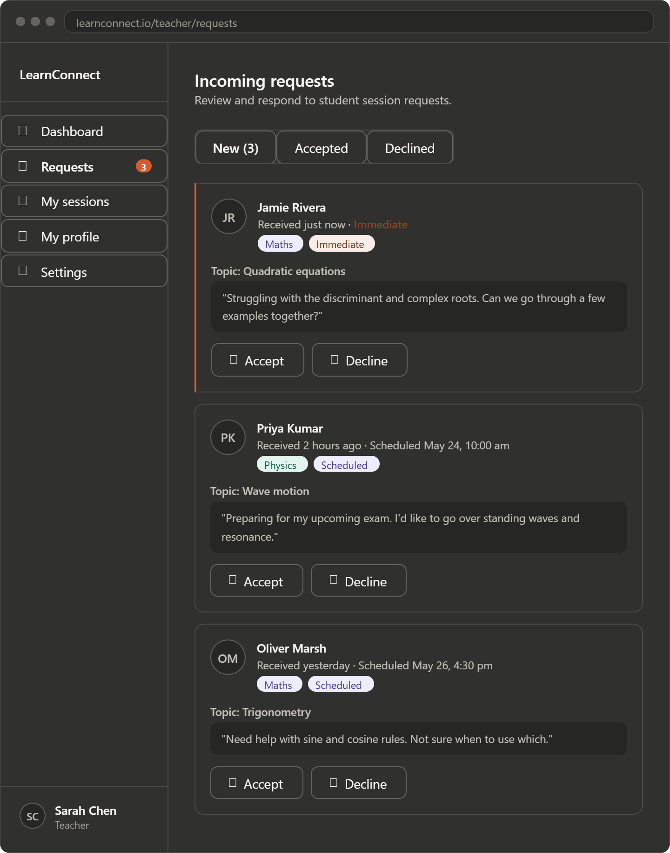
Here is your incoming requests section where you can see requests sent to you and a quick summary of what they are asking. You can click on their profile and see their public profile and then decide whether to accept or decline. When they are accepted they will be added to your my sessions section and you can view the details there. If declined they will be notified and will move to your declined requests section. You will also get a notification if you have any new requests.
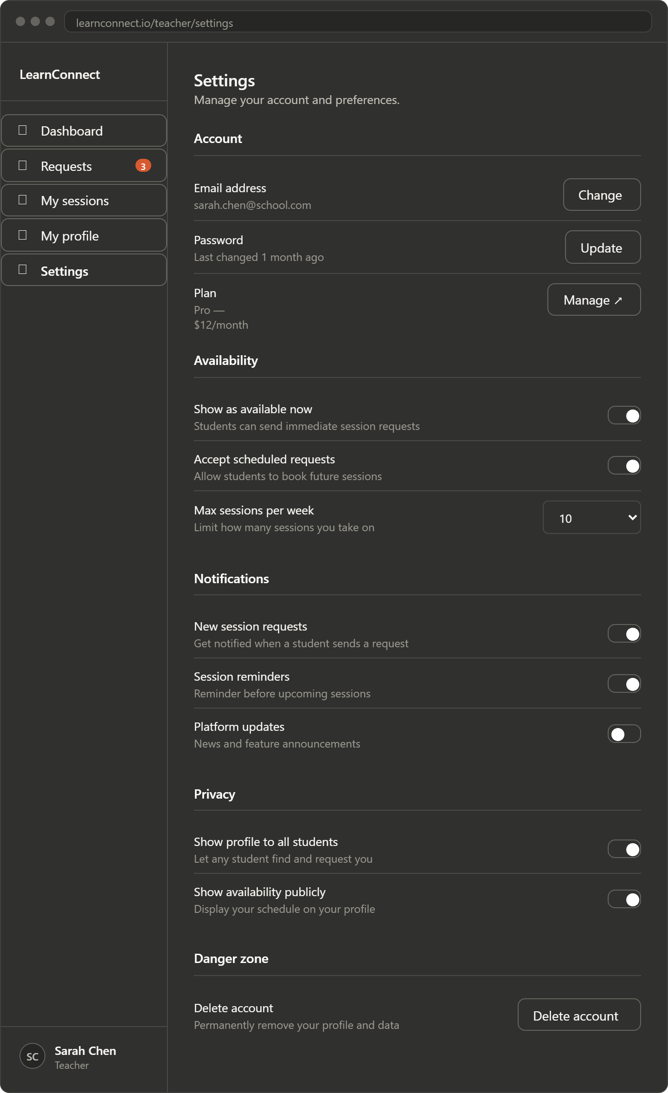
You can change your settings for more customization and comfort for using the website however you would like.

